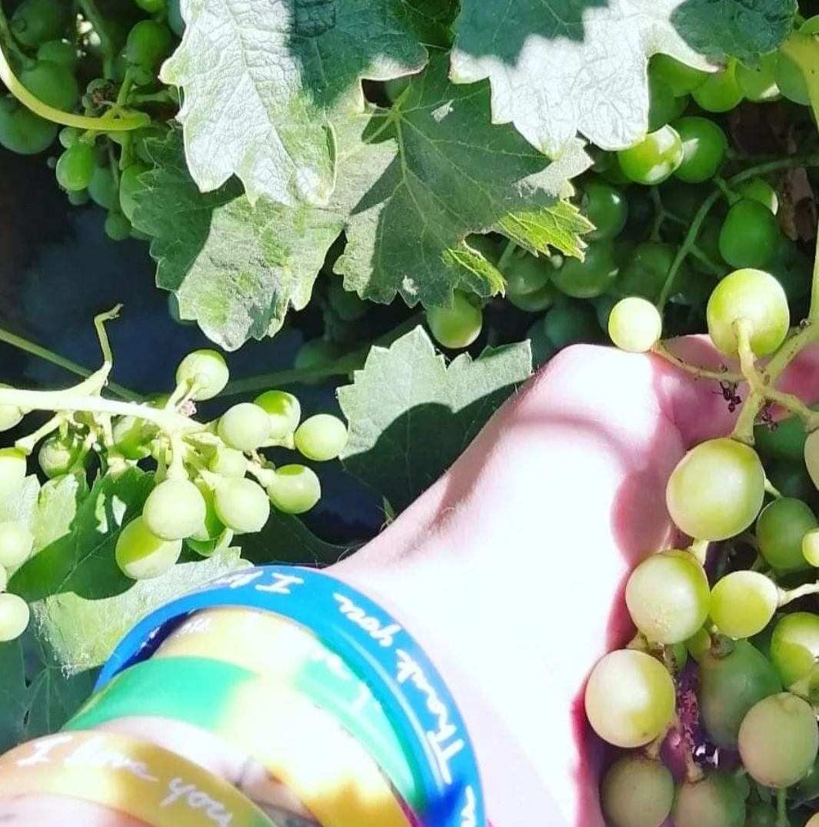

Hello I am
Student of Self I-Dentity through Ho'oponopono ®️

My experience, when Dr Hew Len passed away…. and the news was officially given, that's when I found out, I was cleaning, and I continued like this throughout the day, at one point while I was applying Ho'oponopono through the garden, I went to a grape vine (vine), at my parents' house, who live on the beach and where their garden is very extensive, I chose without thinking that vine to stop and that's when I felt the whispered in the voice of Dr Ihaleakalá Hew Len (a voice I knew only from the videos) and I felt a "face wind", what was he saying to me _ "the Vine is the source and sustenance of the life of the branches, and the branches must remain in the Vine, to live and bear fruit" and then a thought that was _ "we are the LEGACY of Dr Ihaleakalá Hew Len" I cleaned and felt how the vine asked me for a photograph, and I took it, wrote verbatim what I heard…. then it came to my mind to review a biblical text that talks about the Vine.

“I am the vine, you are the branches; he who abides in me, and I in him, this one bears much fruit; because apart from me you can do nothing" (John 15:5)
second time I'm telling this
I kept it for myself and today it has inspired me to share it, thank you.

Thank you

