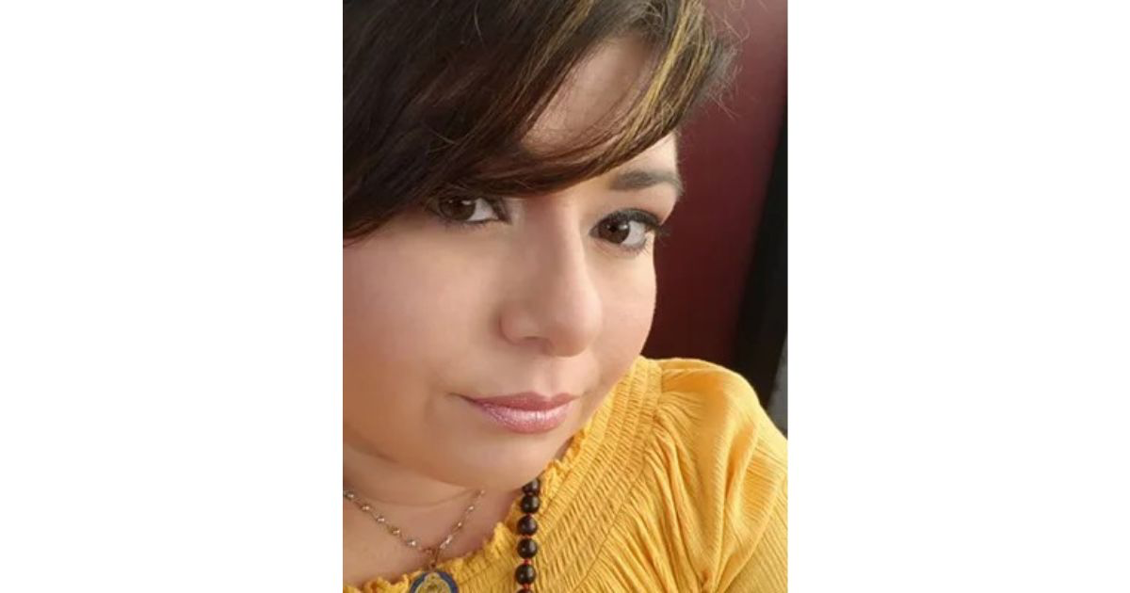

Dieliz Cecile Villegas Surita Interview from Ho’oponopono Asia Official Newsletter

In 2006, I went through a divorce.
When something as painful as divorce happens, I question everything in my life and every choice I have ever made.
At the time, I was desperate, "Why me?
It was at that time that I came across the book "THE SECRET". I liked the story of Joe Vitale in the book, and when I signed up for his newsletter, I received a message about his encounter with Ihaleakala, and I started reading Ihaleakala's book, which was simple and contained the words I was looking for.
Then I came across the IZI LLC website and learned that there was a two-day class in Washington, D.C.
I had an internship with the U.S. federal government during my college years and was familiar with Washington, D.C., so it was not difficult for me to go there by myself from Puerto Rico. I quickly arranged for a ticket and went to see Dr. Ihaleakala Hew Len.
That was to be my first class. When I decided to attend the class, I was in the middle of a divorce property division arrangement. Negotiations were not going well, and I was also in the process of applying for a loan to purchase a car. I was feeling overwhelmed with anxiety at the time, but I was cleaning as we were taught in class.
After the class, on my way back to Puerto Rico from Washington D.C., I received a call that my divorce settlement had been successfully finalized and my car loan application had been approved. The divorce was finalized and signed to my satisfaction, and when I returned home, all of my fears had been put to rest. I realized the benefits of the Self-Identity Through Ho'oponopono that we practiced in the class.
The second class was a business class in Atlanta. That Ihaleakala class was also wonderful. Even with so many people in the room, I was always filled with peace just being in front of Ihaleakala.
I was constantly amazed at myself, but I always felt that it was a solution to a problem that I could actually experience change in.
Most of all, I gained great insight from Ihaleakala's repeated words:
EVERYTHING IS INSIDE JOB.
This means that everything that actually happens on the outside is a reflection of what is happening on the inside. What appears before you as a problem is also caused by what is inside of you.
At the core of SITH Ho'oponopono is the message that "100% of the responsibility for every experience lies with oneself," that everything is one's own responsibility, that one cannot make excuses or blame anyone else, and that one must work on oneself.
This was a big change in my habitual way of thinking.
At the same time, I was convinced that it is a powerful thing that we can step in to solve our problems by our own choices.
In SITH Ho'oponopono classes, there are moments when many of us are convinced. A moment of realizing the truth, not the head. That is what I was taught by Ihaleakala in the class.
And when the class is over, we actually return to the real world, where we are constantly tested on our choice to do or not to do our own cleaning.
There are many different people in the world, and all kinds of problems appear that need to be dealt with. In the midst of it all, we can make a choice. Ihaleakala always spoke to me in a simple way so that my own subconscious mind, not the conscious mind, could remember: to live my true self (Self Identity) or to continue dealing with memories (external causes).
When I attended my first class, there were a couple participants and they were doctors.
In response to the statement that all problems come from within, the man asked, "Are you saying that all those years of going to school and trying to help people heal have been in vain?"
Then Ihaleakala said with his usual look.
"You are the one who is saying that."
It sounds cold at first glance, but the man seemed to understand and calmly took his seat. It was a moment when many of the participants, including myself, realized how many of our thoughts and ideas are based on memory.

I grew up studying Catholicism at a nuns' school from an early age. In Catholicism, when you sin or do something wrong, you must go to a priest and confess your sins. There, in the name of God, the priest offers forgiveness to the confessor.
The first time I went to a priest to confess my sins for communion was when I was eight years old. At that time, the priest was working on fingernails right in front of me. In the time I had spent asking for forgiveness for my sins, the priest was giving nails a beautiful manicure. Even as a child, I strongly wondered at that moment,
Why do I have to go through this person to tell God something? Why can't I connect directly with Divinity?"
It was then that I felt the will to choose the path of direct connection with Divinity.
After that, I no longer chose to go to a priest, no matter what. I had the feeling that if I needed to speak, I would tell God directly. Because of this, I was always treated as a problem child in school.
Catholics are required to prove their Catholicism by receiving Confirmation when they are 16 or 17 years old, after they graduate from high school. Just as you are baptized as soon as you are born, there is a ritual that becomes a sign that you are Catholic once again when you grow up. One part of that ritual process is the need to visit a priest and repent for one's faults.
I went to the priest and said, "I will not do it.
I had a vague idea in my mind at the time that if I wanted to connect with God, I did not need to go through religion. I felt that I did not need any restrictions in order to connect with Divinity.
That is why my encounter with Ho'oponopono helped me to heal what was originally within me, my experience with religion. I realized that what I experience, no matter what the subject matter, is a memory that was originally inside of me, and that only by cleaning with it can I reconnect with Divinity.
Through Ihaleakala, I was able to reconnect with Divinity once again.
Ihaleakala taught me that I was not crazy when I was younger. In the process of reconnecting with the Divinity, I was also able to erase my memories of religion.
There is nothing wrong with attending church and the various rituals involved if Myself is receiving them from inspiration. However, I have always found that it is through freedom that I am able to reconnect with Divinity.
Without the experience of divorce and financial insecurity, I may not have been able to follow this path. When I realized this, I realized how powerful and precious it is to be free from all events, including the past.
SITH Ho'oponopono has been my way of life since that day when Ihaleakala showed me what true peace was all about.
Even now, I still have the opportunity to clean every day.
I am still filled with gratitude for what I am able to do in the moment.

