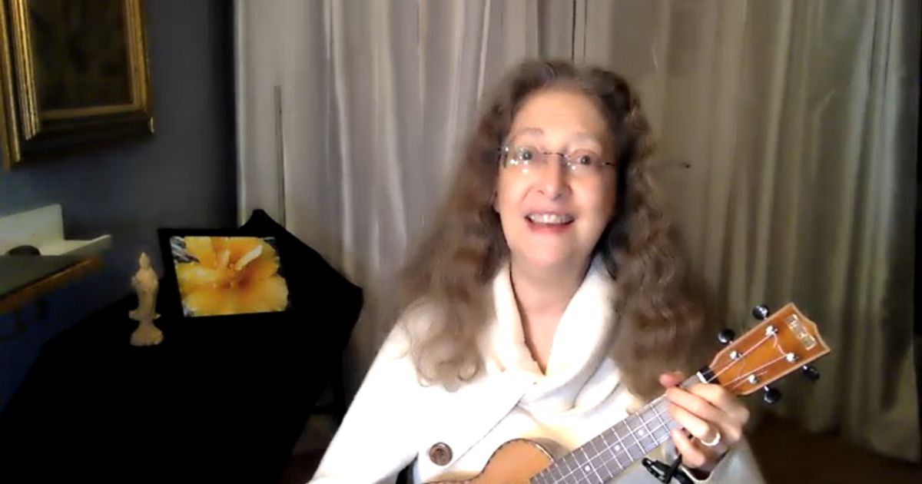

Momilani Ramstrum, Ph.D.
Interview from Self I-Dentity through Ho'oponopono® Asia
Official Newsletter
(abridged from Momilani Ramstrum)

My first encounter with Self I-Dentity through Ho'oponopono® was in 1983. After attending the lecture, taking the class, and meeting our Founder Morrnah Nalamaku Simeona, I joined the staff the following week. A year before that, Ihaleakala had taken the class, met Morrnah, and also joined the staff. During those years Self I-Dentity through Ho'oponopono® gradually took its present form.
At that time, Morrnah used to say to us, ‘You, gathered here, are often up the Kiave tree [a gnarled long-thorned tree in Hawaii] and are the problem children. You are the ones who have created problems for the entire universe. You need to start cleaning with the problems you have created.’
Ihaleakala often accompanied Morrnah when she traveled. At that time, we were all her students and in the process of evolving our own consciousness.
Morrnah was always so clear. When there was a problem, she told us, over and over, “Look at yourself, look at yourself.” Her aura extended for miles, and just being around her was transformative for us. And what is cleaned in one person is cleaned in all of us. She also told us, “You must ride one horse.” For those of us who knew and worked directly with Morrnah, SITH® was all that we did for problem solving. Over and over.
We had lectures every Wednesday, staff meetings on Thursdays, and trainings every weekend. We spent 50 weeks of the year doing this and Ihaleakala was always there. We realized that SITH® wasn’t just something we did. SITH® was our way of life, saved our lives and was necessary for our lives.
Morrnah often said that when we grieve for someone, our grief is an invisible hook to hold on to the deceased. It can be very sad to lose a loved one, but if when we feel this, we do our cleaning, then we can release the other person, who is set free. And most importantly we set ourselves free and any connected beings, atoms and molecules.
Attachments keep us tied, whether the attachment is of love or not. Even if we feel that person's presence brings us happiness, if we hold onto them or a particular moment, then this attachment can limit our future and stop the flow. Instead, we can keep reminding ourselves that Divinity, through our Inner Connection, can provide us unlimited resources and freedom.

Ihaleakala, his I-Dentity, is timeless and still exists. When we let go of our attachment to him and our memories of him, it sets him and ourselves free. When we can see the Divinity in ourselves and in others, we can begin to become free.
Ihaleakala has given so much throughout life. For many years he taught classes almost every weekend somewhere in the world. That is an incredibly challenging thing to do. And he ‘just got to the cleaning,’ with whatever was happening.
Ihaleakala once shared a story with me. While he was giving a class in Philadelphia, during lunch a woman sat down next to him and started talking without stop. He suddenly said to a woman "Do you know what verbal diarrhea is?" He wasn't angry with the person, he just said it, as he was inspired - simply and plainly. She immediately understood and stopped the conversation.
He knew how to enjoy life. He appreciated sitting in a quiet garden, sharing good food. He loved listening to beautiful music, especially Mozart, and playing the piano. He would smile as he played the ukulele, laughing and singing. And he had a beautiful big laugh.
One night Ihaleakala was a guest in our home, and he helped me as he always did. This time he took out the trash and I noticed that he was cleaning out the inside of the trash can. I was surprised and asked him why. He replied, ‘The trash can asked me to clean it, so I did.’
The memory I have of him is that he was always trying to be responsible for cleaning what was in front of him at any given time. For him, it was as natural as breathing. Watching him, I could see that cleaning memories was a way of discovering his Self I-Dentity and allowing freedom of all other identities as well.
I don't feel a lack in not being able to see him now. Instead, I feel an immense amount of gratitude for the constant cleaning he has been doing.
It is beyond comprehension how much freedom he has brought to me and the entire universe through his cleaning and letting go of everything he encountered as a human being.
After I spent any time with him, Ihaleakala would send a handwritten thank you card. And in it, he would always say:
"Thank you for giving me one more opportunity, one more chance, to clean with you, your family relatives and ancestors."

Thank you Ihaleakala. I love you.

