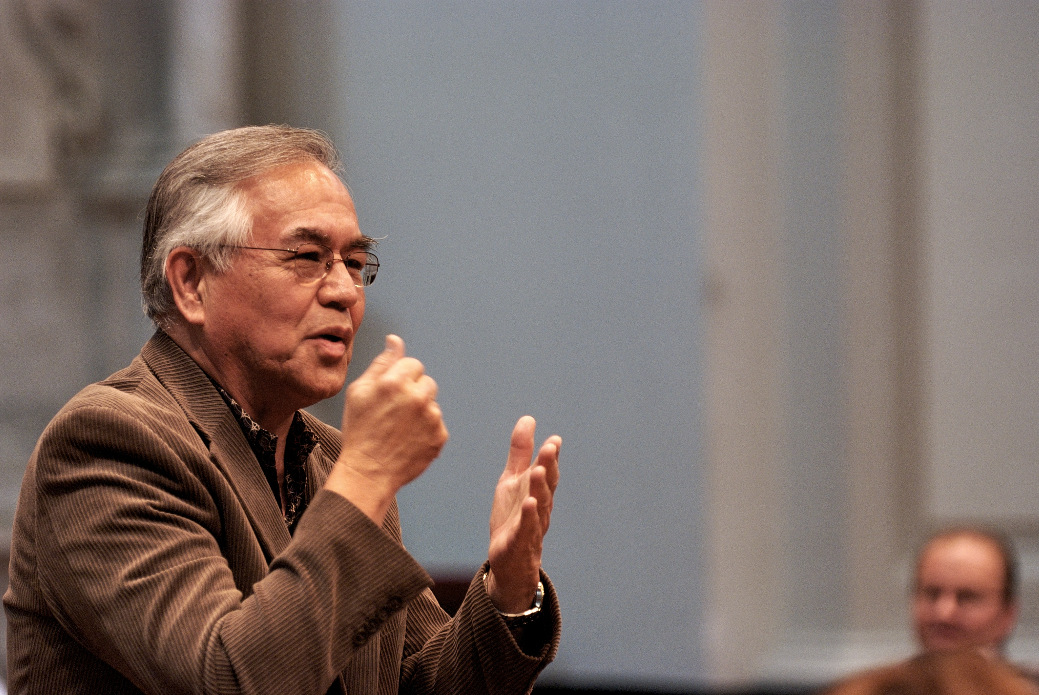

Coming home: Interview from a Student in Amsterdam
On October 15th, 2007 I met Ihaleakala Hew Len for the first time. Together with my friend, we invited him to give a talk for Meet the Masters, a lecture cycle for the financial sector. The lectures were held in De Duif, a beautiful church in Amsterdam. When I arrived Hew Len wasn't there yet. My friend was picking him up from his hotel. Fifteen minutes later Hew Len and my friend got out of a taxi. An older man wearing sneakers and a baseball cap shook my hand and said, "Ah, you're the funny guy," and walked into the church. “Strange guy”, I thought. When we got in, he said, "Hmm, an ancient church, death, sorrow, pain, lots to clean here, thank you." “A strange guy indeed”, I thought. Then he looked my friend in the eye and said: 'Come on, you can't receive people like that, we're going for a walk first.' My friend was in panic and said: “More than 200 guests will arrive in half an hour and so much still to be done'. Hew Len: "How can you expect them to get to their Self when there are so many turbulent thoughts within yourself?"
They walked away and I saw four people in the church Hew Len took with him from the United States. They didn’t say a think and sat quietly on a chair, each in their own corner of the church. “Strange people”, I said to myself. Much later I understood they were cleaning.
The 200 people of the financial sector enjoyed the class of Hew Len very much. I stunned. This literally felt like coming home. I didn't understand what he was saying with my heard but I listened with my heart. For decades I had philosophized about God, the meaning of life etc, but achieved little to nothing. And on that day I suddenly realized that in the end there is nothing outside of ourselves, what our purpose on earth is, who we are, who is in charge and how we solve problems. What a liberation!
Ho'oponopono is the nicest, simplest and easiest way back to our origin. You don't need gurus, you don't need insurance, you don't need to be in pain, you don't even need to understand... All you have to do is practice... And of course... without expectations.
Hew Len has given me the greatest gift of my life: home within myself. We met each other a few times after and he asked me to give a number of classes about Ho'oponopono. He asked me to write a book about Ho’oponopono and he helped me to find my lovely wife in 2013. I thank Hew Len for all the miracles in my life, miracles which I describe as smiles from God. Thank you!

