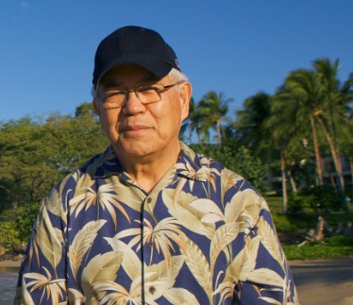

Memory of IHHL: Student in Denmark

I met Ihaleakala in Istanbul 2012, in my early twenties and difficult time in my life. He had the most calm appearance that made me realize that everything was alright.
What I learned from Dr. Ihaleakala Hew Len back then and since changed my life and I will be forever grateful.
Thank you.

