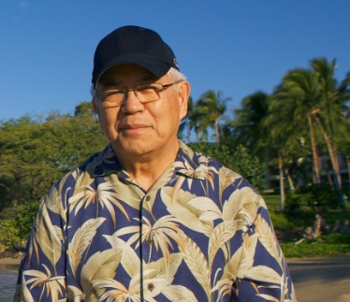

Memory of IHHL: Student in New Hampshire

A very dear friend of mine told me about the practice of Self I-Dentity through Ho'oponopono® and I attended a class in 2011 in Milpitas, CA. Dr. Hew Len taught the class. I was fortunate to talk with Dr Len. He asked me what I did for work and I told him that I promote the use of alternative transportation such as transit and carpooling instead of driving alone in your car to work. He asked me how I did that and then told me that the way to do it is through love. Since that day I have been practicing Ho'oponopono each day and each action I take I do it through love. Dr. Len taught me a life's lesson that I shall carry for the rest of my life - address everything through love.

