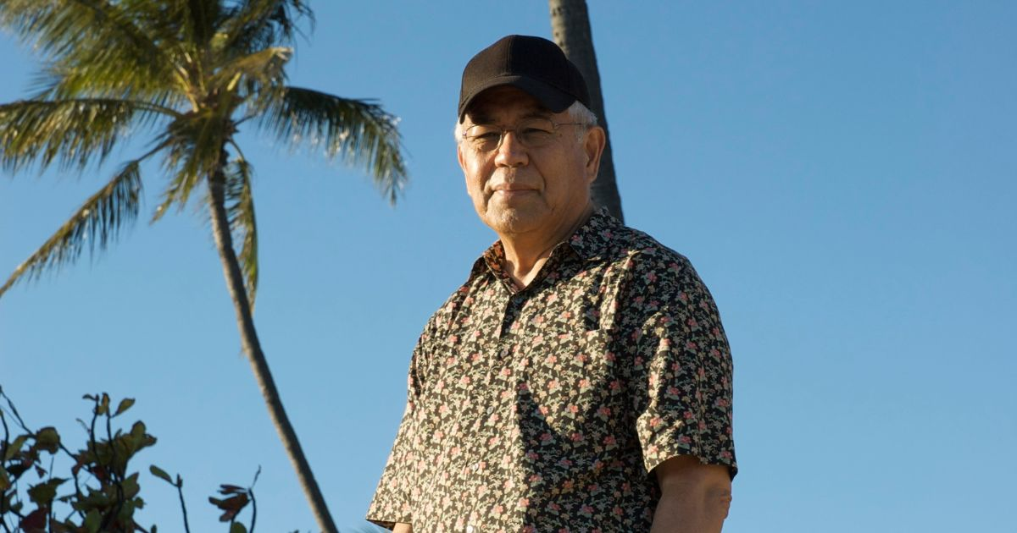

Memory of IHHL: Student in Germany

Ihaleakala was for me already the first time I attended Basic I a very
authentic, trustworthy and humourous person. I don't trust people
quickly but IHHL impressed me with his convincing way to explain
Ho'oponopono and from then on I decided to clean which has changed my life.
His devotion to Divinity set an example.

