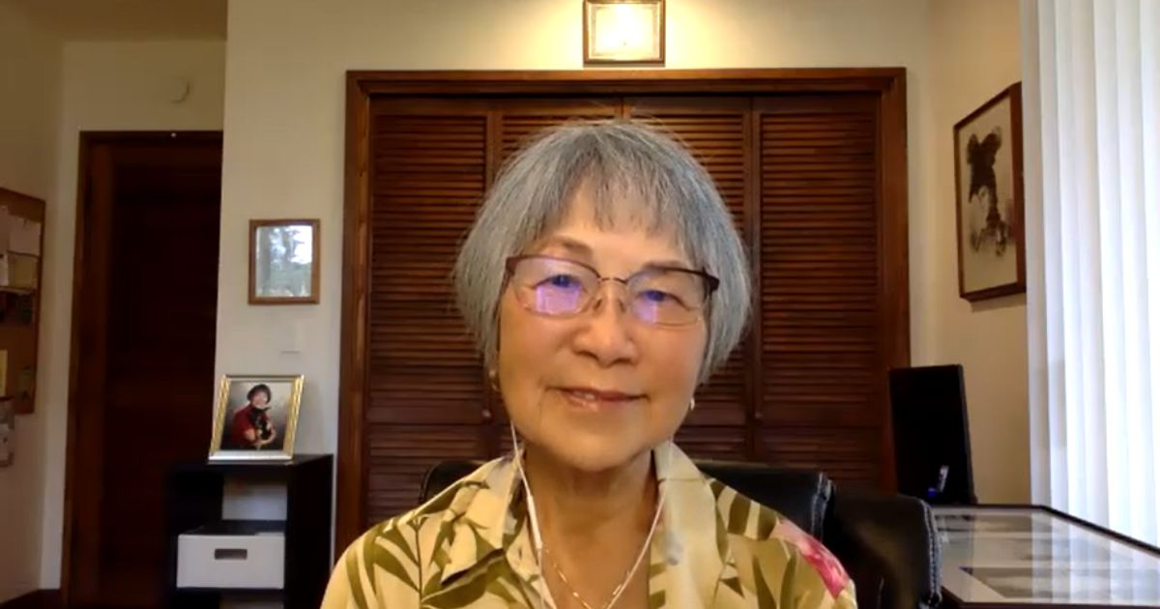

Dr. C. Jarnie Lee Interview from Ho’oponopono Asia Official Newsletter

The Coming of Ihaleakala

One day around mid 1982, Morrnah Nalamaku Simeona called to me, “Jarnie, can you mediate with me.” As we meditated, Mornnah asked, “What do you see Jarnie?”
(“I see what looks like the beginning of the Hawaiian Islands. Everything is barren. Only the land is there. It looks smooth with beautiful color in it like pink … looks like the island of Maui with the formation of the monolithic Iao Needle in the Iao Valley.”) Morrnah: “What do you see next?” (“Oh, I see a little brown man wearing a loin cloth.”)

Morrnah: “What color is it?” (“Oh, it's red.”) Morrnah: “Ohhh. What do you see next?” What else do you see?” (“Oh, I see a pool of water. And this pool is round about this big {showing her with my arms forming a circle with fingertips touching}, and about this high." {showing her about a foot deep, the water being very clear and pristine, being able to see right through it}.

Morrnah: “Can you see the bottom?” (“Yes, I can.”) Morrnah: "What else do you see? Do you see anything at the bottom?” (“Yes, there is a stone that looks like this {forming a circle with my hands with fingertips touching} about this flat (showing an inch thick) a dark gray almost black color and very smooth.”)

Morrnah: “Oh! Can the man pick it up?” ("Yes, he can,” as I saw him dipping his hand through the crystal-clear water reaching for the stone.) Morrnah: “Can this man crush the stone with his mind?” (“Yes, he can."). Morrnah: “Can he crush it into large pieces?” (“Yes, he can!) Morrnah: "Can he crush it into smaller pieces?” (“Yes, he can!!”)

Morrnah: “Can he crush it even smaller like sand?” (Yes, he can!!!”). Morrnah: "Can he crush it even finer to look almost like powder?” (“Yes! He can do that!!”) Morrnah: Can he eat it?” ("Yes!! He can eat it !!!”). Morrnah: “Ohhhh!!! I’ve been waiting for him to show up!!! A few months later, Dr. Stanley Hew Len, PhD showed up.

[Morrnah had been foretold by the “I” (ka “I) that a man would be showing up to help her with her work in sharing with the world, starting with the 50th state of Hawaii, the Ancient Hawaiian way of Life and Problem Solving called Ho'oponopono, which Morrnah developed and updated to become “Self I-Dentity Through Ho’oponoono,” (SITH).

When Dr. Stanley Hew Len first arrived, he was like a “diamond in the rough.” He was a gem, but unpolished, though with many facets. Through Morrnah, the “I” gave Stanley the name “Ihalealaka.” When he transitioned, he was no longer a diamond in the rough, but highly polished, exquisite, glowing bright and brilliant light, radiating Love, Peace and Joy.

I personally remember Ihaleakala for his dedication and tenaciousness to just “get-to-the-cleaning," his Inspirational truth-telling, "it’s only you," kindness and great sense of humor. I fondly remember his identifying our replaying memories (m’s) as “do do,” (always brings a smile to my lips and gut laughter).

Years ago, after a lunch break during a huge SITH class in Kona, Hawaii, I happened to meet up with Ihaleakala on the way back to class. I asked him, “Would you like to hear a song?” “Sure, he replied,” smiling delightfully. So, I sang lyrics that my unihipili had composed to the tune, ‘Only you.”

ONLY YOU

Only you can make the darknesss bright,
Only you can change your wrongs to right,
Only you decides to suffer so, or let your do do go
Only you can choose to be yourself once more.

Bursting with laughter, Ihaleakala requested, “Jarnie, I want you to sing this to the class.” So, when the class resumed, Ihhl asked the students to close their eyes and listen, announcing, "Jarnie’s going to sing to you.”
When it came to the part about "letting their do do go,” a roar of laughter…lol… occurred.

Mahalo nui loa Ihaleakala Aloha oe

