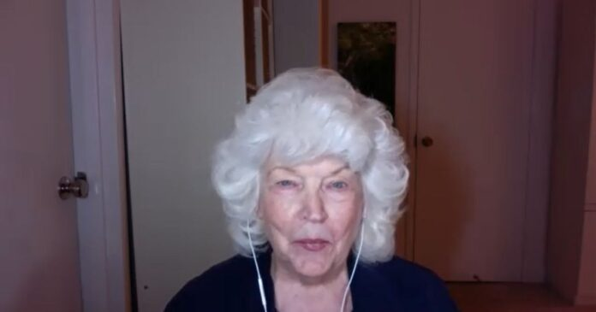

Constance ZHoke=Pana Webber Interview from Ho’oponopono Asia Official Newsletter

For 40 years, being able to have a connection with Ihaleakala has been a great blessing in my life.
In 1975, I met Morrnah in Hawaii, and in 1980, she visited the mainland United States for the first time, where I was able to set up Ho’oponopono classes. From there, I began working with Morrnah. In 1983, Morrnah brought Ihaleakala to my home in Philadelphia for the first time, which became the meeting with Ihaleakala.
At that time, we organized a symposium titled “Identity of Man,” which laid the foundation for the current Self-Identity through Ho’oponopono. Ihaleakala served as the moderator for this event. Since then, even as the current format of the classes took shape, we have co-hosted numerous classes together. Throughout this process, what I learned from Morrnah and what I learned from Ihaleakala always aligned. Everything Ihaleakala talked about was related to Self-Identity through Ho’oponopono.
Until Morrnah’s passing in 1992, Ihaleakala traveled with her on all her journeys. Afterwards, Ihaleakala began conducting classes on his own and took on the role of operating the Foundation of I. He expressed gratitude for every opportunity he encountered through these roles.
“He walked the talk.”
He was undeniably a person of “action speaks louder than words.” He practiced cleaning through living. Ihaleakala had the talent to explain what Ho’oponopono was in a simple and humorous way. He was a delightful and caring individual in his personal life as well.
Among the phrases that Ihaleakala often said, there was one that I particularly liked:
“Clean erase erase and find your own Shangri-La. Where? Within yourself.”
I still believe that this is the fundamental essence of everything. When we first met, the tools we used in our classes were simply four PowerPoint slides and videos. We didn’t have the impressive technical support that we have now. We had only chalk, blackboards, and erasers. Even in such a setting, Ihaleakala’s brilliance was established from the very first class he conducted as a speaker. I was moved when he used the blackboard to illustrate and diagram what Morrnah had been teaching until then.
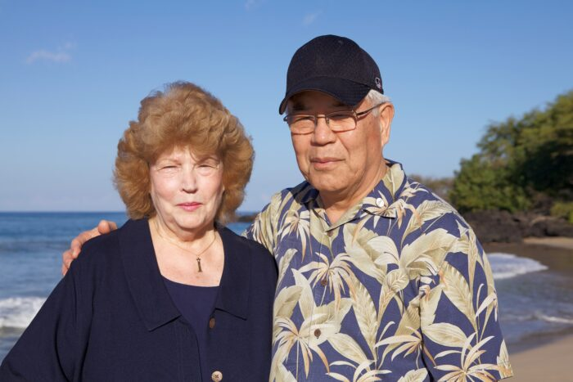
My husband and I were fortunate to have the opportunity to welcome Morrnah and Ihaleakala into our home whenever they visited for classes. When Ihaleakala visited, we set up a foldable bed in my humble study, where there was only a small desk and a computer. Once, when he was packing his belongings into a very small, old-fashioned suitcase, he happened to find an eraser in my study and said to me:
“If you don’t mind, could you let me take this with me? It helps me remember to erase (memories).”
He seemed to have carried it during his journeys from city to city, but when the tour was over and it was time to depart, he carefully placed it back on top of a drawer in the room. I understand why he did that. Since then, whenever I see it, it reminds me of cleaning.
Through spending time with Morrnah and Ihaleakala, I truly learned that “you can only touch your true essence by erasing and erasing.” And it is the greatest gift for our existence to know that there is a way to understand our own existence and to experience it. Its benefits are immeasurable. Instead of living in fear, worry, or self-blame, we can remember that we can clean in every moment.
In this moment, I sincerely express my gratitude for all the cleaning Ihaleakala has done. At the same time, it is important to emphasize that he only cleaned his own memories, no matter the circumstances or the world he faced. That greatness is something I deeply feel. Because he did that, my husband, myself, my business, and my family have also been cleaned.
He is my Ohana (family). Although he only met my mother four times, he was always kind to her. He sent her roses and letters of gratitude. But even in that process, he was cleaning himself. I am deeply grateful for his kindness. My mother lived to be 99 and a half years old.
Ihaleakala was truly a person filled with kindness. Even in this moment, I am cleaning my feelings of missing him. This desire to meet him is also a memory within myself.
Throughout the 40 years, every time Ihaleakala visited our home, he left us a letter of gratitude addressed to my husband and me. But I want to share one of them here because it is meant for everyone who practices Ho’oponopono.
“I thank you for joining with me and with Morrnah in the sacred task of leading the children back to the Source.
The re-education of a man is the re-education of self. More specifically who we are.
I never said, Morrnah never said this would be easy. In fact both had said that track back home would not be easy. Looking at self and taking total responsibility for all of our problems. And for all of the problems around us goes contrary. To our addictions and addictions of blaming, judging, talking, thinking and arrogance.
Yet to be have prevailed, not uncased but we have prevailed. I thank you both for being my family and joining all around foundation on peace of earth and throughout the cosmos. May the coming days and months be a continual journey of self discovery and finding the source within. Peace. Peace. Peace.”
Ihaleakala and Morrnah always conveyed messages about connecting to the source, and among those messages, the most important thing is that everything is within oneself. By taking 100% responsibility for oneself, one can regain a perfect connection within oneself first, and then with the external world. I am grateful to Ihaleakala for teaching me this, even in this present moment.

